**BRIDGE TE AROHA: lovely place, lovely game ♠♥♦♣**

**Te Aroha News March 2025**

 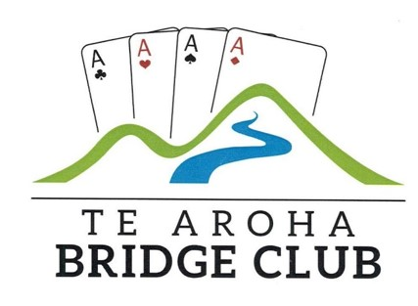

**1-2-3**

There are usually some 200-300 pairs taking part in X Club on any weekday night, especially a Tuesday night. Around 20 of them are playing in the Te Aroha club session. On the night of Tuesday March 4th, there were 310 pairs. It was thus quite an achievement that the top three pairs all came from Te Aroha:

|  |  |  |  |  |  |  |  |
| --- | --- | --- | --- | --- | --- | --- | --- |
|  |  |  |  |  | **X Club** |  | **Te Aroha** |
|  |  |  |  |  | **Score** |  | **Score** |
|  |  |  |  |  | **%** |  | **%** |
| 1st | Peter Daffurn | | Hanna Frischknecht | | 64.67 |  | 65.36 |
|  |  |  |  |  |  |  |  |
| 2nd | Shirley Townsend | | Rochelle van Heuven | | 64.46 |  | 65.36 |
|  |  |  |  |  |  |  |  |
| 3rd | Alan Mace |  | Richard Solomon | | 63.86 |  | 68.18 |

Sometimes your result is higher on X Club than at the club and sometimes it is not! This night saw all three of the scores at the club drop on X Club and Alan and my score dropped the most. However, all three pairs were not beaten on X Club with Hanna and Peter having bragging rights that night.

**From Garden**

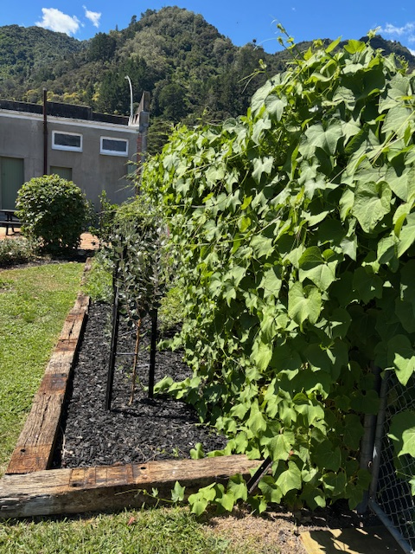

**To the table!**

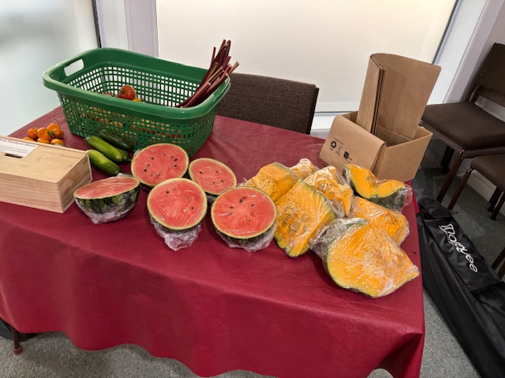

Someday soon, our club will be the main “vege” supplier to Woolworths next door. Paul may have retired from work but he is as busy as ever in his garden, in the club garden and any plot of land he might find producing heaps. Another good reason to come to bridge each week is the fine fruit and vegetables you can take home. Good on you, Paul.

**Domain Day**

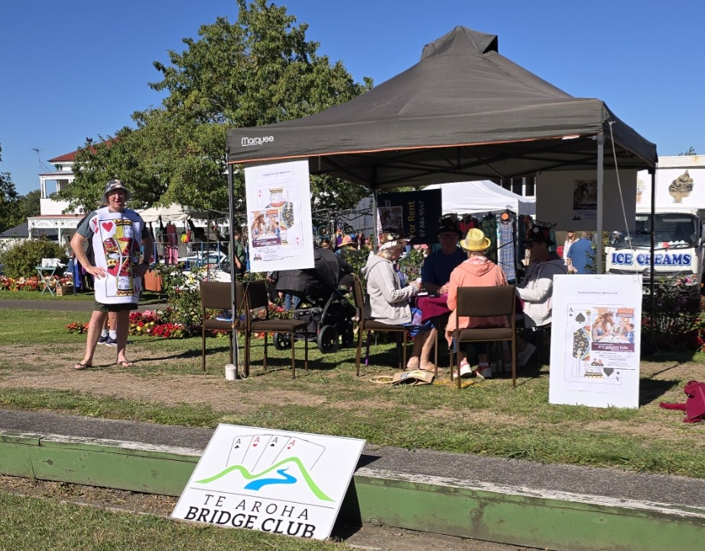

We had good club representation at the annual Domain Day on March 9th. A beautiful day and plenty of people strolling past the stand. Our members played away and really did look like they were enjoying themselves. Thanks to all for coming. ..and the end result?

It shows it is hard to convince our public to give bridge a go. However, at least one of the group of new players who have started with Charlotte and Tyrel on Thursday nights came as a result of Domain Day.

We have a good group starting, hopefully up to three tables including a couple who are just checking up on what they learnt last year.

**Speed Puzzler wins again**

That’s Charlotte who has come out on top again in a regional speed jigsaw competition. Her team, which includes her father Peter, a friend and her sister-in-law, completed the 1,000 piece jigsaw in just over 51 minutes, over 3 minutes ahead of their closest rivals and over 9 minutes ahead of the 3rd placed team.

As well as Teams competitions, there are individual and Pairs competitions. Charlotte also takes part in on-line competitions where everyone is sent the same puzzle and you all do it together over zoom video.

The New Zealand Nationals are in July and Charlotte will be there. It will be the second NZ national event. Speed puzzling is quite new with lots of countries just starting to hold national events. World Championships started in 2019.

Charlotte is the first to acknowledge her “back room crew”, her mother and Tyrel who have the very important role of looking after baby Sophie while she is busy fitting the pieces in to the puzzles.

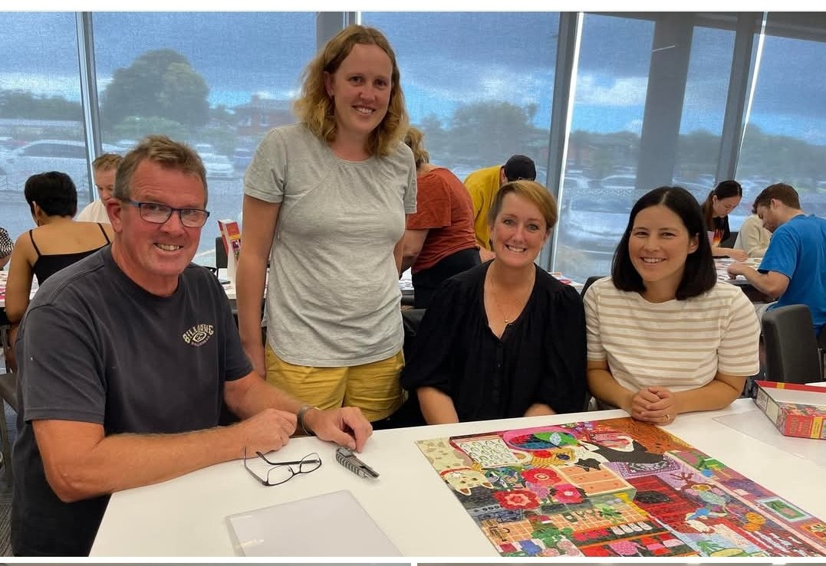

**The Wedding Corner**

 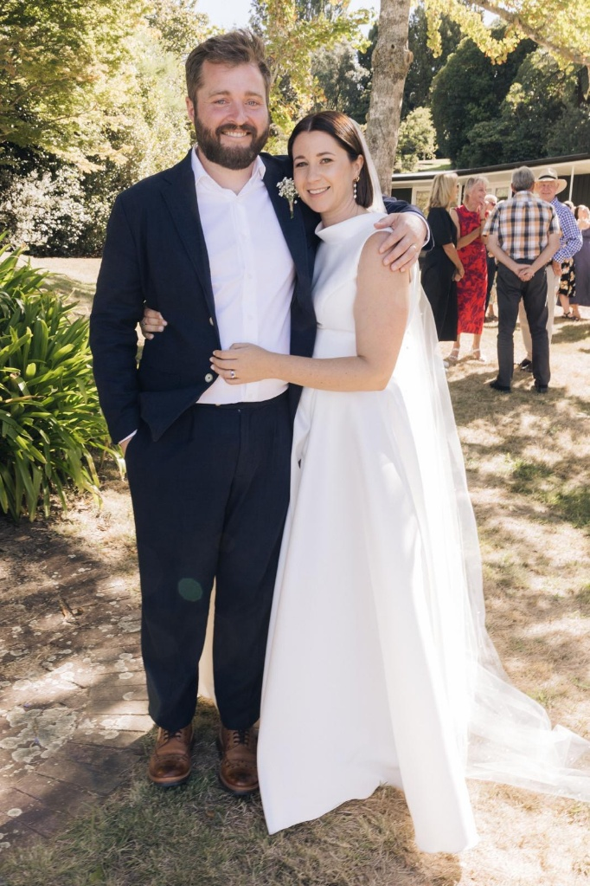

There’s a bit of that happening about the club at present. Cam and Emma tied the knot at the end of March but the official photos will not be available until the April issue. Then, too, we have the latest Kalma wedding as Grace and Oscar have their big day on Good Friday.

So, in the March issue, we see both a bride and groom but also the bride and her father walking down the aisle by the shore of Lake Tarawera on a beautifully sunny day in early March. A clue to the bride is in the proud father. You may not recognise him as you may not have seen him dressed like that before!

That’s his daughter, Anna and in the other photo, she is with the bridegroom, Tim. It is not often that Richard misses a major bridge tournament at a weekend though this was a very special reason for doing so.

**The Wisdom of Solomon**



**TJ is right, too!**

It was Peter TJ who gave me this tip courtesy of top NZ player Graeme Tuffnell.

Just do the normal things and most of the time you will get a good result from doing so. Occasionally, you will not but generally go with the normal thing and you will either get an average result or even a rather good one.

Take this deal.

|  |  |  |  |  |  |  |  |  |  |  |
| --- | --- | --- | --- | --- | --- | --- | --- | --- | --- | --- |
| South Deals None Vul | |  |  | | --- | --- | | ♠ | A 10 6 5 | | ♥ | K J 6 | | ♦ | Q 8 4 | | ♣ | J 9 2 | | |
| |  |  | | --- | --- | |  |  | | |  |  |  | | --- | --- | --- | | N | | | | W |  | E | | S | | | | |  |  | | --- | --- | |  |  | |
|  | |  |  | | --- | --- | | ♠ | K J 8 4 3 | | ♥ | Q 10 5 | | ♦ | A K J | | ♣ | Q 4 | | |

|  |  |  |  |
| --- | --- | --- | --- |
| *West* | *North* | *East* | *South* |
|  |  |  | 1 ♠ |
| Pass | 3 ♠ | Pass | 4 ♠ |
| All pass |  |  |  |

Most pairs will reach 4♠️ with an auction similar to the above. You cannot avoid 2 club losers or ♥️A. So, the success or failure of the contract depends on not losing a trick to ♠️Q.

Let’s say West leads ♦️10. You win and play trumps. The normal play, without any clue from the opponents’ bidding is to play ♠️A and then a spade to the king(assuming West did play a spade on the first round). Alas, no joy and you lose a spade trick..down one. Average board because other pairs did the same. That’s what we are taught to do with 9 cards missing the queen.

|  |  |  |  |  |  |  |  |  |  |  |
| --- | --- | --- | --- | --- | --- | --- | --- | --- | --- | --- |
| South Deals None Vul | |  |  | | --- | --- | | ♠ | A 10 6 5 | | ♥ | K J 6 | | ♦ | Q 8 4 | | ♣ | J 9 2 | | |
| |  |  |  |  |  |  |  |  |  |  | | --- | --- | --- | --- | --- | --- | --- | --- | --- | --- | | |  |  | | --- | --- | | ♠ | 7 | | ♥ | 9 8 7 4 | | ♦ | 10 9 3 | | ♣ | K 8 7 5 3 | |  | | |  |  |  | | --- | --- | --- | | N | | | | W |  | E | | S | | | | |  |  |  |  |  |  |  |  |  |  | | --- | --- | --- | --- | --- | --- | --- | --- | --- | --- | |  | |  |  | | --- | --- | | ♠ | Q 9 2 | | ♥ | A 3 2 | | ♦ | 7 6 5 2 | | ♣ | A 10 6 | | |
|  | |  |  | | --- | --- | | ♠ | K J 8 4 3 | | ♥ | Q 10 5 | | ♦ | A K J | | ♣ | Q 4 | | |

|  |
| --- |
| 4 ♠ by South |

Maybe one South got lucky when West led their singleton trump (a big “no-no”, normally!). Meanwhile, if you take a losing spade finesse and the spades broke 2-2, you will get a very poor score much of the time. Do the normal thing and you will score reasonably well, whether you make or fail in your contract. A good bridge player tries to keep bottom boards to an absolute minimum. One way is to do the normal thing, unless there is clear evidence to the contrary.

Thanks, Graeme….and Peter TJ.

**Two Nice Weeks against Thames… except the results!**

Thames came to Te Aroha and Te Aroha went the other way on two Tuesdays in March. They were two neat well supported evenings. Nice atmosphere, delicious suppers but oh, the results!

At Te Aroha, only Jan and Pat shone for the locals with a fine 63.64% but the other five of the top six scores came from Thames players. It was the same again the following week with Tim and Peter being the highest place “TA” pair finishing 6th with 58.64%. It looks like we will need an improvement for the repeat rounds in October. There’s a nice trophy ready to present to the winning club.

**No longer on the Board**



Anna Kalma has been on the Board of New Zealand Bridge for the past 4 years. She spent many more years on the Waikato Bays Regional Committee. She has now called time on her Board role. During that time, she has been a big contributor of her time and expertise, especially in the areas of Marketing, Sponsorship, Bridge Teaching and more recently Youth Bridge.

Pulling back will still mean she is available to help local clubs, as she has done here in Te Aroha for many years…and will still be playing the game heaps. I for one am very keen for that to happen! Thanks for your big contribution to the development of the game in New Zealand.

**APRIL DATE at Te Aroha**

That’s the Waikato Area Pairs on Sunday April 29th at the club, a 2-session Open tournament, that’s “open” to all players including Intermediate and Junior players. The recent Matamata heat had 17 tables. Let’s have plenty of locals here at “TA”. $15 per player and if you would like to play but do not have a partner, then do let me know.

Oh and keep in mind Spa Town Teams along with Restricted Swiss Pairs at Silver Fern Farms Event Centre on Saturday 7th June.

**Some Great News to Finish**

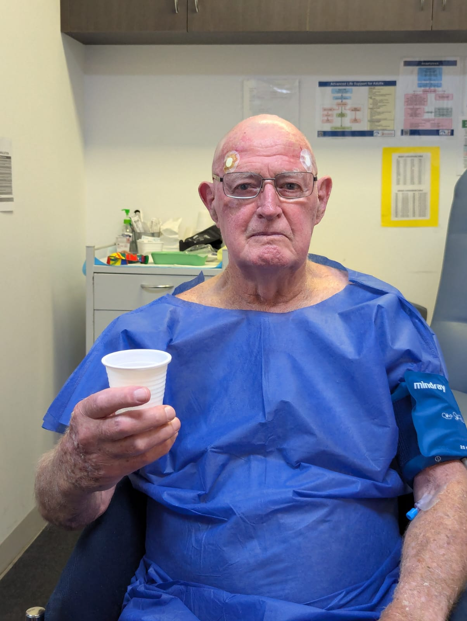

Here is Alan fresh from his successful operation in Melbourne, with a very steady right hand. He will not be drawn as to whether the cup contains port or something milder but all seems to have gone very well and he will be back playing again very soon. *Plenty more Happy Bridging in April. Richard*